DB Failover ( reboot ) can be done via Console ,AWS CLI ,RDS API

<https://docs.amazonaws.cn/en_us/AmazonRDS/latest/UserGuide/USER_RebootInstance.html>

DB Failover Steps via Console

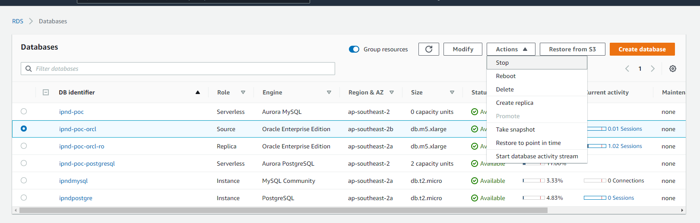

Select the DB :

To failover – Plase click a reboot

Before the reboot note down the Avaibilty Zone and after failover you can check again

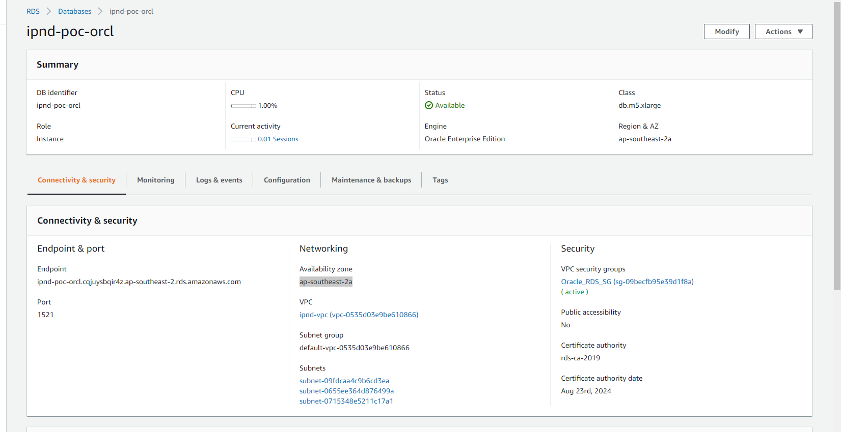

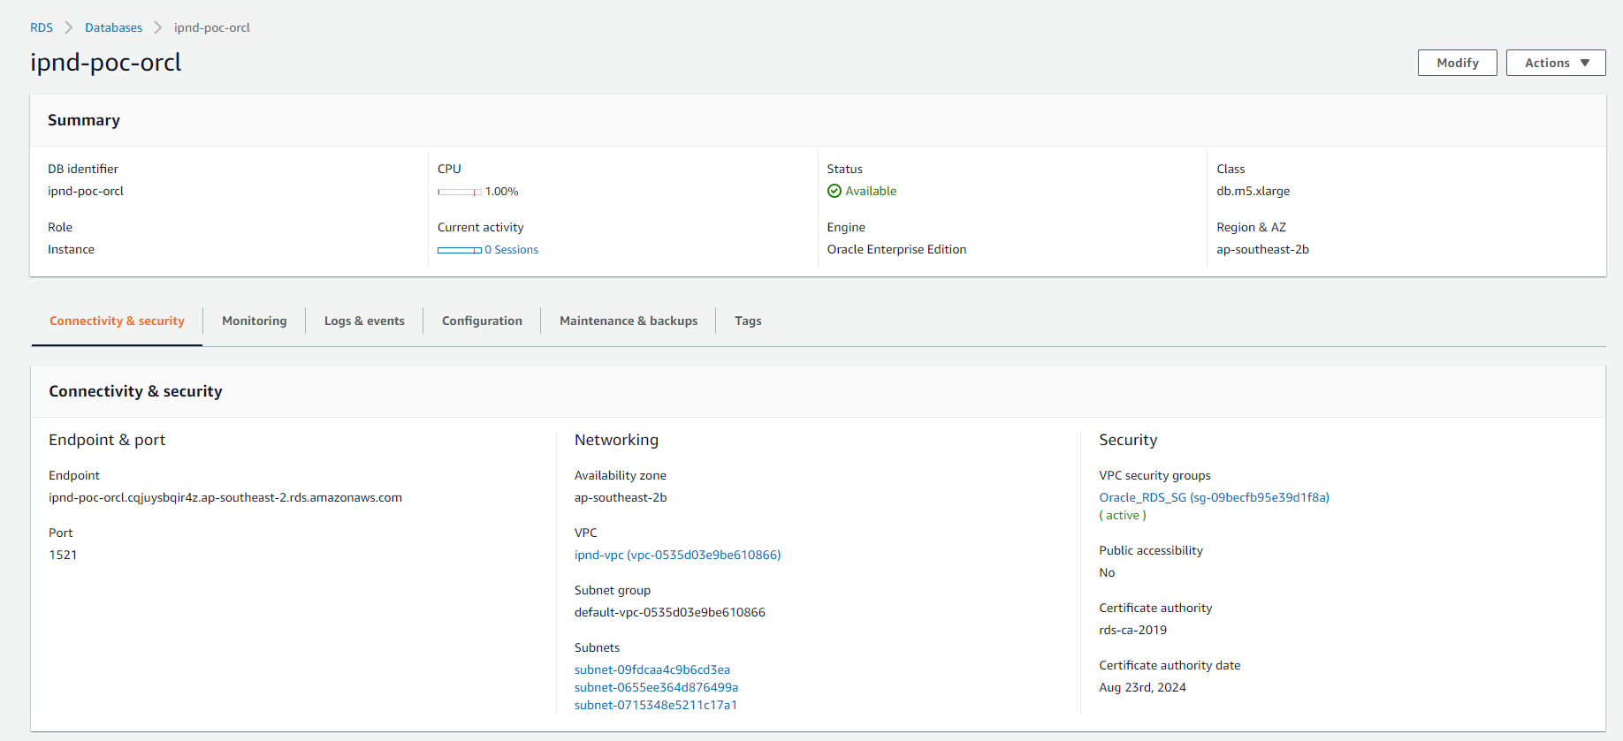

Create Read replica

Go to the actions menu and click read replica



Reference

<https://aws.amazon.com/rds/features/multi-az/>

Why should you be careful with the first AWS RDS Oracle Multi-AZ failover?

<https://daniel8192.wordpress.com/2020/01/20/why-should-you-be-careful-with-the-first-aws-rds-oracle-multi-az-failover/>

# failover-db-cluster

<https://docs.aws.amazon.com/cli/latest/reference/rds/failover-db-cluster.html>